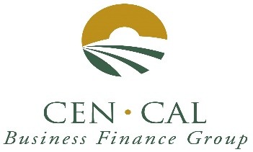
April 2023 Newsletter

SBA 504 20-year rates 5.952%, fixed.

SBA 504 25-year rate 5.880%, fixed.

SBA 504 25-year REFI rate 5.898%, fixed.

SBA 504 10-year rates 6.768%, fixed.

City Revolving Loan fund rate 11.5%, fixed.

Rates dropped in April.

Rate information: Rates Decreased 38 basis points (0.38%). We do expect more rate adjustments in the next 6 months. Inflation is still up but wages remained unchanged last month.

The SBA’s turnaround time for approvals is 3.0 business days, and servicing action times are also 4.0 business days.

Year to date we have 11 SBA approvals. Tri Counties Bank had Three loan approvals with us in March. Tri Counties Bank now leads with 4 SBA approvals followed by Premier Valley Bank with 2 approvals and 5 banks with 1 one approval each for WestAmerica Bank, Access+Capital, United Security Bank, Fresno First Bank and Citizens Business Bank. THANK YOU to all our participating banks for your referrals.

City of Fresno RLF MICRO LOANS. Both Our Legacy RLF fund and the Business Recovery RLF fund are completely advanced (No Availability). The total Legacy RLF fund is over $750,000. Our Business Recovery RLF fund is $830,000. We are meeting or exceeding all our goals for our 2 RLF funds. Cen Cal has been an “A Rated” EDA Micro Lender for the past 5 years.

The SBA 504 Real Estate Program continues to be a great way to finance the acquisition and/or construction of commercial real estate for owner-users. 504 loans can be used to finance up to 90% of the cost of your real estate project. 504 Loan can also be used to finance up to 85% of the cost of special use properties, such as cold storage facilities, urgent care, and surgery centers.

Please visit our website at https://cencalfinance.com/
On FACEBOOK at https://www.facebook.com/cencalfinance/?ref=bookmarks
Or on LinkedIn at https://www.linkedin.com/company/cen-cal-business-finance-group

For Additional Information Contact: Cal Cain at (559) 905-5636 or (559) 227-1158

