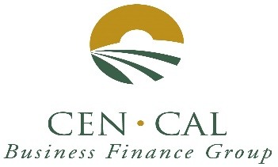
May 2022 Newsletter

SBA 504 20-year rates 5.057%, fixed.

SBA 504 25-year rate 5.117%, fixed.

SBA 504 25-year REFI rate 5.130%, fixed.

SBA 504 10-year rates 4.922%, fixed.

City Revolving Loan fund rate 6.50%, fixed.
City Business Recovery Loan Fund Rate: Prime + 0%.

Rate information: Rates jumped up by 0.442 Points. Since November 2021, rates are up 2 points, and they are expected to continue to move up throughout 2022. The Banks appear to be starting to raise rates too. The Feds are expected to raise rates 2 or 3 more times this year, due to growing concerns over inflation and the Russia-Ukraine War. Materials are expected to increase 15 to 20 percent this year and Labor costs are expected to increase as much as 15 percent too. The SBA turn around times for approvals is 11 business days, and servicing actions times have improved to 6 business days.

Through April, we have 17 SBA approvals. In March Tri Counties Bank had 3 more approvals. Year to date, Tri Counties leads with 8 Loan approvals, followed by Fresno First Bank with 3, Central Valley Community Bank, WestAmerica Bank and Community West Bank with 2 approvals each. Mechanics Bank, Valley Republic Bank, and Premier Valley Bank each have one loan approval. THANK YOU to all our participating banks for your referrals.

BUSINESS RECOVERY RLF MICRO LOANS are still available for working capital loans for businesses recovering from the effects of Covid-19 in the City of Fresno. Thank you.

Please visit our website at https://cencalfinance.com/
On FACEBOOK at https://www.facebook.com/cencalfinance/?ref=bookmarks
Or on LinkedIn at https://www.linkedin.com/company/cen-cal-business-finance-group

The SBA 504 Real Estate Program continues to be a great way to finance the acquisition and/or construction of commercial real estate for owner-users. 504 loans can be used to finance up to 90% of the cost of your real estate project. 504 Loan can also be used to finance up to 85% of the cost of special use properties, such as cold storage facilities, urgent care and surgery centers.

For Additional Information Contact: Cal Cain (559) 905-5636 or (559) 227-1158

CEN CAL MILESTONES
Congratulations to our recent Interns on their graduations from Fresno State.

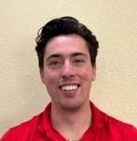
James Waid, current Intern. Graduating May 2022

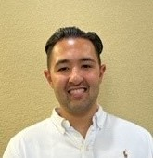
Carlson West, Past Intern, Fall 2021. Graduated in December 2021

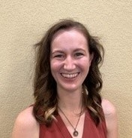
Laura Liles, Past Intern, Summer 2021. Graduating May 2022

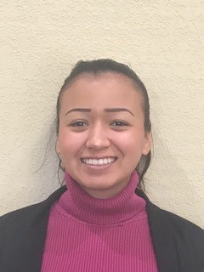
Karen Munoz, Past Intern, 2020-21. Receiving her MBA May 2022

Cen Cal wishes all 4 of these Bulldogs lots of success and happiness.

