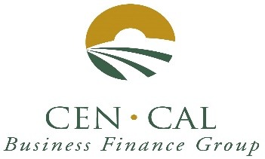
MERRY CHRISTMAS TO ALL

Rates Remain Stable at 2.583%

December 2020 Newsletter

SBA 504 20-year rates 2.583%, fixed.

SBA 504 25-year rate 2.622%, fixed.

SBA 504 25-year REFI rate 2.663%, fixed.

SBA 504 10-year rates 2.417%, fixed.

City Revolving Loan fund rate 6.25%, fixed.
City CARES RLF Loan Fund Rate: Prime +0%.

Rate information: December rates decreased by 6 basis points. 20- and 25-year rates are below 2.60%. We are not sure what to expect from rates in the short-term due to the Corona Virus and a new Administration.

We have 9 SBA loans approved from 8 different Lenders so far, this fiscal year. Tri Counties Bank has the early lead with 2 approvals. Central Valley Community Bank, Fresno First Bank, BBVA Compass Bank, Bank of the Sierra, CB&T/Zions, Citizens Business Bank, Seacoast Bank all with loan approval each. THANK YOU to all our participating banks for your referrals.

CARES ACT RLF MICRO LOANS. Cen Cal has CARES ACT RLF Micro-Loan program for businesses in the City of Fresno. These are working capital loans for business recovering from Covid-19 effects on the economy. Thank you. Please be safe.

Please visit us on the web at www.cencalfinance.com
On FACEBOOK at https://www.facebook.com/cencalfinance/?ref=bookmarks
On LinkedIn at Cen Cal Business Finance Group

The SBA 504 Real Estate Program continues to be a great way to finance the acquisition and/or construction of commercial real estate for owner-users. 504 loans can be used to finance up to 90% of the cost of your real estate project. 504 Loan can also be used for up to 85% for special use properties, such as cold storage facilities and surgery centers.

For Additional Information, Please Contact: Cal Cain (559) 227-1158

