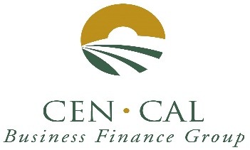
Rates drop further below 3%

June 2020 Newsletter

SBA 504 20-year rates 2.522%, fixed.

SBA 504 25-year rate 2.597%, fixed.

SBA 504 25-year REFI rate 2.599%, fixed.

SBA 504 10-year rates 2.644%, fixed.

City Revolving Loan fund rate 6.25%, fixed.

Rate information: June rates decreased by 16 basis points. 20- and 25-year rates are well below 3.00%. We are not sure what to expect from rates in the short-term due to the Corona Virus. Please keep in mind that Banks can refinance their own debt with the 504 Refinance program.

Cen Cal Business Finance Group wants to recognize all our Lenders for their Hard Work processing PPP loans and Deferments. Our lenders are all doing a Great Job. Cen Cal is here to support you in any way we can. Thank you. Please be safe.

Our Activity has picked up so far in June. We are at 17 approvals in 7 months. Central Valley Community Bank has the lead with 6 approvals, followed by Bank of Sierra with 3; BBVA Compass Bank with 2 approvals, followed by Fresno First Bank, American Riviera Bank, United Security Bank, BBVA Compass, Premier Valley Bank, Chase Bank and Pacific Premier Bank with one approval each. THANK YOU to all our participating banks for your referrals.

Please visit us on the web at www.cencalfinance.com
On FACEBOOK at https://www.facebook.com/cencalfinance/?ref=bookmarks
On LinkedIn at Cen Cal Business Finance Group
In Person at 5094 N. Fruit Ave., Suite 103, Fresno, CA

The SBA 504 Real Estate Program continues to be a great way to finance the acquisition and/or construction of commercial real estate for owner-users. 504 loans can be used to finance up to 90% of the cost of your real estate project. 504 Loan can also be used for up to 85% for special use properties, such as cold storage facilities and surgery centers.

For additional information
Contact: Cal Cain (559) 227-1158

