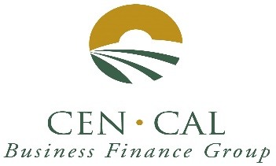
Rates steady and below 3.75%.

January 2019 Newsletter

SBA 504 20-year rates 3.639%, fixed.

SBA 504 25-year rate 3.710%, fixed.

SBA 504 25-year REFI rate 3.712%, fixed.

SBA 504 10-year rates 3.791%, fixed.

City Revolving Loan fund rate 7.25%, fixed.

Rate information: January rates increased slightly by 6 basis points. It looks like the Fed will continue to hold the rates down and we should see small rate increases by year-end but remain below 4%. We continue to see increased pressure from regulators on our lenders to tighten up on credit in 2019 due to the fear that the real estate market may be over heating or banks having concentration issues in their loan portfolio; SBA 504 loans are still a good choice to get your deals to the finish line for your customers and keep your credit managers less grumpy. Please keep in mind that Banks can refinance their own debt with the 504 Refinance program.

We are off to a little bit of a slow start this fiscal year. We only had 5 approvals in the first quarter. Central Valley Community Bank has the early lead with 3 approvals, followed by American Riviera Bank and United Security Bank with one approval each. THANK YOU to all our participating banks for your referrals.

Cen Cal has updated our Website. Please visit us at www.cencalfinance.com
YOU CAN NOW FIND US ON FACEBOOK AT https://www.facebook.com/cencalfinance/?ref=bookmarks

The SBA 504 Real Estate Program continues to be a great way to finance the acquisition and/or construction of commercial real estate for owner-users. 504 loans can be used to finance up to 90% of the cost of your real estate project. 504 Loan can also be used for up to 85% for special use properties, such as cold storage facilities and surgery centers.

For additional information
Contact: Cal Cain
(559) 227-1158

